1. What is the emissions per capita of Canada?

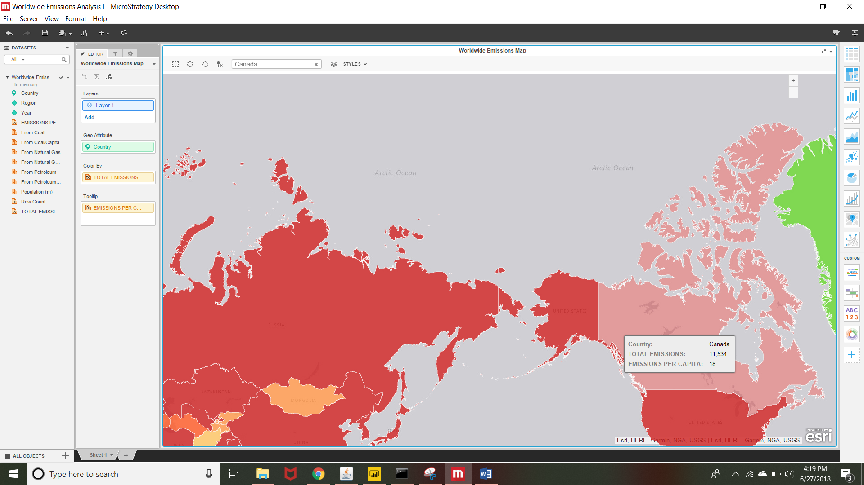

2. What is the overall trend in worldwide emissions?

Worldwide emissions keep on increasing as observed from the visualizations.

3. Notice that overall emissions declined in 2009, the only year in the total number of

years surveyed that indicates emissions decreases in all three emissions sources. Why

is that? What broader socio-political context might explain this single yearly

decrease?- The increase in population remained constant, however the total emissions decreased. Hence the overall emissions declined in 2009.

